Yohanes Dimas Pratama

A11.2021.13254 - A15.9102

Reusable Water Bottle

1. Product Name

Reusable Water Bottle

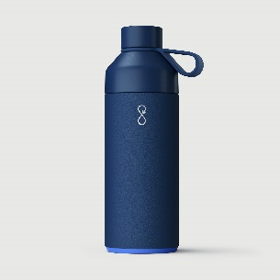

1. Materials of the Product

Made from high-quality, BPA-free, and food-grade stainless steel.

1. The Advantages of the Product

* Environmentally Friendly

Reduces the need for single-use plastic bottles, contributing to a decrease in plastic waste.

* Durability

Stainless steel construction ensures a long lifespan for the bottle.

* Temperature Retention

Keeps beverages hot or cold for an extended period.

1. The Disadvantages of the Product

* Weight

Stainless steel bottles can be heavier than their plastic counterparts.

* Cost

Initial purchase cost might be higher compared to disposable plastic bottles.

1. The Package to Use

* Eco-Friendly Packaging

Minimalistic and recyclable packaging to align with the product's eco-friendly nature.

* Informational Insert

Include a small leaflet or tag providing information on the environmental benefits of using a reusable bottle, care instructions, and product features.

This example demonstrates how a reusable water bottle made from stainless steel can offer environmental advantages and durability. The disadvantage is the potential weight compared to plastic, and the package emphasizes eco-friendliness and includes useful information for the consumer.